Background & Instructions: This email template was created to help applicants for CEC certification programs request employer support for their intent to pursue board certification. It clearly outlines the associated costs and time commitment, while highlighting the value and benefits to the organization when an employee earns and maintains board certification.
We recommend that you tailor the language to meet the needs of your specific request as well as the benefits you think are most relevant for your organization.
_______________________________________________________________________________________________________
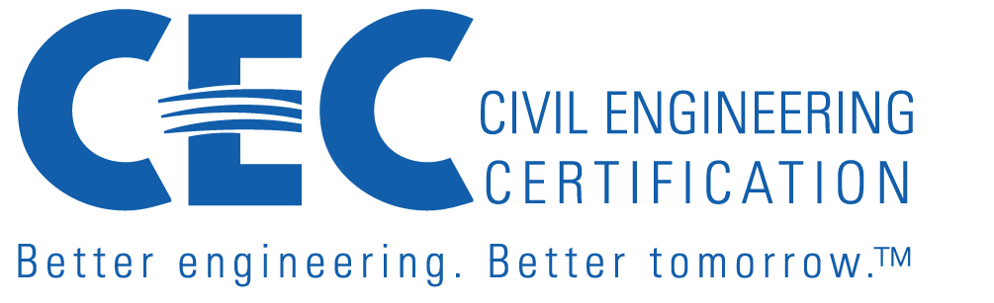
Subject: Request for Support to Pursue Technical Board Certification through ASCE Civil Engineering Certification
Dear [Manager's Name],
I’m writing to request your support—both financial and professional—as I pursue board certification in [insert specialty area, e.g., Geotechnical Engineering] administered by Civil Engineering Certification, Inc. (CEC) and the American Society of Civil Engineers (ASCE).
CEC’s Board Certifications are industry-recognized credentials that go beyond P.E. licensure to validate advanced technical expertise, leadership, and a commitment to ethical practice and continuing professional development. Board certification is only granted to professional engineers who have demonstrated advanced expertise in their specialty area.
Just as board certification distinguishes physicians who meet rigorous standards of expertise and ethics, board-certified civil engineers demonstrate advanced expertise, leadership, and commitment to public safety, sustainable practices, and professional excellence.
Why Board Certification Benefits Our Organization:
- Strengthens Our Market Position: Board-certified engineers enhance our credibility and competitiveness in securing and successfully executing civil infrastructure projects, especially in qualifications-based selection processes and government contracts—both domestic and international.
- Demonstrates Organizational Commitment to Excellence: Supporting board certification shows that we invest in high standards and continuous improvement, which reflects positively on our company, brand, and culture.
- Improved Technical Quality and Risk Management: Certified engineers bring deep expertise and sound judgment, improving our project outcomes, reducing costs and errors, and mitigating risks.
- Supports Talent Development and Retention: Providing pathways for professional growth helps retain top talent and foster a culture of excellence and engagement.
- Promotes Leadership and Mentorship: Board-certified professionals often serve as technical leaders and mentors, helping to elevate the performance of junior staff and strengthen internal capabilities.
- Aligns with Strategic Goals: Certification supports our goals around innovation, quality assurance, workforce development, and contributing to long-term organizational success.
CEC promotes board-certified engineers, providing additional visibility and recognition for employers through:
- Board-Certified Engineer Directory Listings – Board-certified engineers are listed in a public directory, increasing visibility and potential business opportunities for their employers.
- LinkedIn Recognition Posts – CEC highlights newly-certified professionals, offering immediate exposure and positive branding for their companies.
Cost and Commitment:
- Application Fee: $350 ASCE/Institute Member or $450 Non-Member. Payment must accompany completed application upon submission.
- Annual Recertification Fee:
- ASCE and/or Institute Members: $200/year
- Nonmembers: $250/year
Continuing Education Requirement: A minimum of 20 Professional Development Hours (PDHs) annually, including 2 PDHs in ethics, is required to maintain certification.
I would greatly appreciate support in covering these costs and the time commitment required to pursue and maintain this credential. I believe this investment will yield significant returns for both my professional growth and our organization’s continued success.
I am happy to provide more details about the certification process and discuss how it aligns with our team’s strategic priorities.
Thank you for considering this request.
Best regards,
[Your Full Name]
[Your Job Title]
[Your Contact Information: Company Name, Phone, Email]

